1. 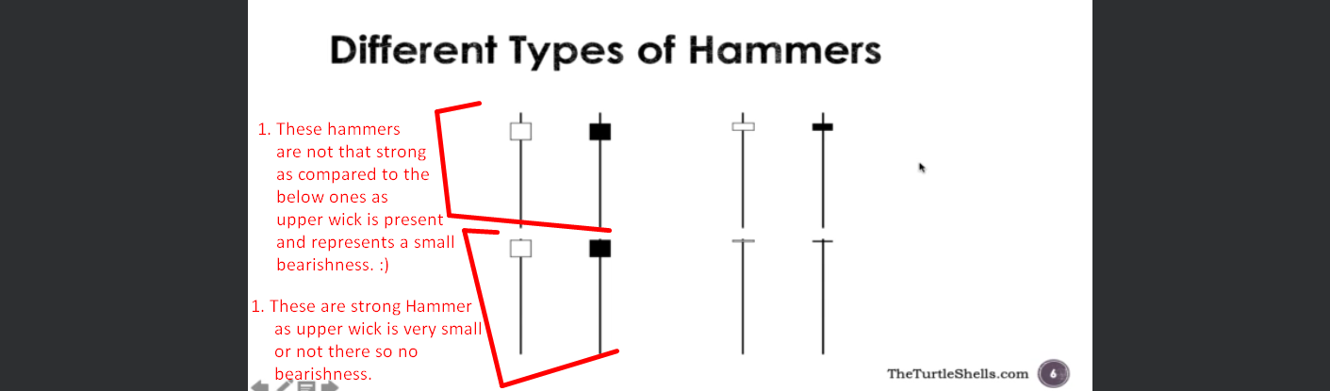
2. A white board with red text and arrows

   Description automatically generated
3. A graph with a line graph and red text

   Description automatically generated with medium confidence